LIVE HUMAN BEING DETECTION WIRELESS REMOTE CONTROLLED ROBOT (USEFUL FOR DETECTION OF TERRORISTS HIDING INSIDE BUILDINGS)

ABSTRACT:

The main aim of this project is to detect the human being by using a wireless remote controlled Robot, which have the sensors that detects the presence of the human being and indicates the presence to user. As it is a wireless Robot it can be easily mobilized and can be controlled. This can be used to detect terrorists/thief inside the building.
RF Communication ranges in between 30 KHz to 300 GHz. RF communication works by creating electromagnetic waves at a source and being able to pick up those electromagnetic waves at a particular destination. These electromagnetic waves travel through the air at near the speed of light. The wavelength of an electromagnetic signal is inversely proportional to the frequency i.e., the higher the frequency, the shorter the wavelength.
In this project we use micro controller, which is programmed to control the input and output modules interfaced to it. The controller makes use of a PIR based input sensor to sense the human being and give us an alert indication.
The controlling device of the whole system is a Microcontroller to which RF receiver, PIR sensor and DC motors are interfaced. The remote control has control buttons interfaced to RF transmitter. Whenever a button is pressed, the data related to that button will be transmitted through RF transmitter. This data will be received by RF receiver and is fed to the Microcontroller. The Microcontroller processes this data and acts accordingly on Robot motors. PIR sensor is interfaced to the Microcontroller which continuously monitors human presence and intimates to the controller. The controller alerts through Buzzer if human presence is present. The Microcontroller is programmed using Embedded C language.

REGULATED POWER SUPPLY:

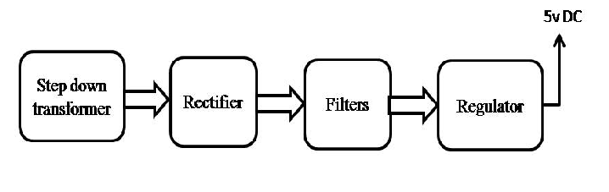

BLOCK DIAGRAM:
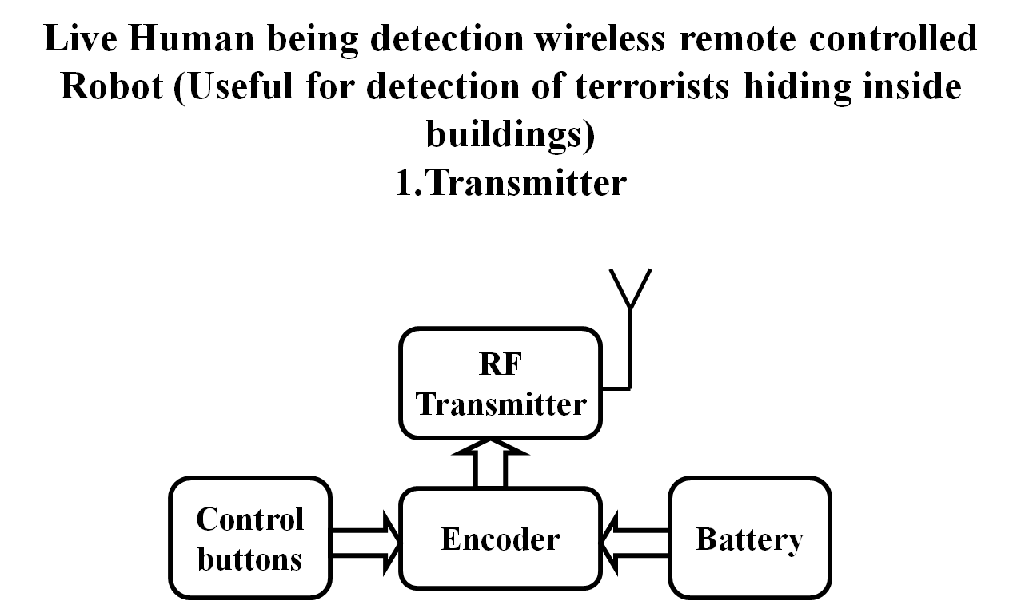

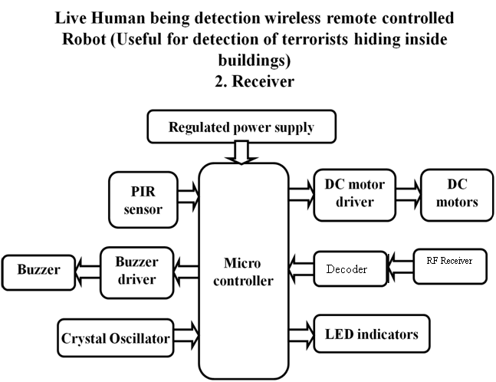

SOFTWARE:
EMBEDDED C
KEIL SOFTWARE
HARDWARE:
- RF TRANSMITTER
- RF RECEIVER
- ENCODER
- DECODER
- CRYSTAL OSCILLATOR
- BUZZER
- CTRL BUTTONS
- BATTERY
- PIR SENSOR
- LED
- POWER SUPPLY
- MICRO CONTROLLER
ADVANTAGES:
LOW COST
RELIABLE CIRCUIT
HIGH PERFORMANCE

APPLICATIONS:
- Wireless control of robot directions and movement.
- Real time human detection.

Power supply:
Voltage regulator

Filter
Bridge rectifier
Step down T/F

POWER SUPPLY:
The input to the circuit is applied from the regulated power supply. The a.c. input i.e., 230V from the mains supply is step down by the transformer to 12V and is fed to a rectifier. The output obtained from the rectifier is a pulsating d.c voltage. So in order to get a pure d.c voltage, the output voltage from the rectifier is fed to a filter to remove any a.c components present even after rectification. Now, this voltage is given to a voltage regulator to obtain a pure constant dc voltage.
230V AC
50Hz
D.C Output

Regulator

Filter
Bridge Rectifier
Step down transformer

Fig: Power supply
Transformer:
Usually, DC voltages are required to operate various electronic equipment and these voltages are 5V, 9V or 12V. But these voltages cannot be obtained directly. Thus the a.c input available at the mains supply i.e., 230V is to be brought down to the required voltage level. This is done by a transformer. Thus, a step down transformer is employed to decrease the voltage to a required level.
Rectifier:
The output from the transformer is fed to the rectifier. It converts A.C. into pulsating D.C. The rectifier may be a half wave or a full wave rectifier. In this project, a bridge rectifier is used because of its merits like good stability and full wave rectification.
Filter:
Capacitive filter is used in this project. It removes the ripples from the output of rectifier and smoothens the D.C. Output received from this filter is constant until the mains voltage and load is maintained constant. However, if either of the two is varied, D.C. voltage received at this point changes. Therefore a regulator is applied at the output stage.
Voltage regulator:
As the name itself implies, it regulates the input applied to it. A voltage regulator is an electrical regulator designed to automatically maintain a constant voltage level. In this project, power supply of 5V and 12V are required. In order to obtain these voltage levels, 7805 and 7812 voltage regulators are to be used. The first number 78 represents positive supply and the numbers 05, 12 represent the required output voltage levels.

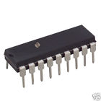
AT89S52 MICROCONTROLLER

MICROCONTROLLERS:
Microprocessors and microcontrollers are widely used in embedded systems products. Microcontroller is a programmable device. A microcontroller has a CPU in addition to a fixed amount of RAM, ROM, I/O ports and a timer embedded all on a single chip. The fixed amount of on-chip ROM, RAM and number of I/O ports in microcontrollers makes them ideal for many applications in which cost and space are critical.
The Intel 8052 is Harvard architecture, single chip microcontroller (µC) which was developed by Intel in 1980 for use in embedded systems. It was popular in the 1980s and early 1990s, but today it has largely been superseded by a vast range of enhanced devices with 8052-compatible processor cores that are manufactured by more than 20 independent manufacturers including Atmel, Infineon Technologies and Maxim Integrated Products.
8052 is an 8-bit processor, meaning that the CPU can work on only 8 bits of data at a time. Data larger than 8 bits has to be broken into 8-bit pieces to be processed by the CPU. 8052 is available in different memory types such as UV-EPROM, Flash and NV-RAM.
The present project is implemented on Keil uVision. In order to program the device, proload tool has been used to burn the program onto the microcontroller.
The features, pin description of the microcontroller and the software tools used are discussed in the following sections.

FEATURES:
• Compatible with MCS-51® Products
• 8K Bytes of In-System Programmable (ISP) Flash Memory
– Endurance: 1000 Write/Erase Cycles
• 4.0V to 5.5V Operating Range
• Fully Static Operation: 0 Hz to 33 MHz
• Three-level Program Memory Lock
• 256 x 8-bit Internal RAM
• 32 Programmable I/O Lines
• Three 16-bit Timer/Counters
• Eight Interrupt Sources
• Full Duplex UART Serial Channel
• Low-power Idle and Power-down Modes
• Interrupt Recovery from Power-down Mode
• Watchdog Timer
DESCRIPTION

The AT89S52 is a low-power, high-performance CMOS 8-bit microcontroller with 8K bytes of in-system programmable Flash memory. The device is manufactured using Atmel’s high-density nonvolatile memory technology and is compatible with the industry- standard 80C51 instruction set and pinout. The on-chip Flash allows the program memory to be reprogrammed in-system or by a conventional nonvolatile memory programmer. By combining a versatile 8-bit CPU with in-system programmable Flash on a monolithic chip, the Atmel AT89S52 is a powerful microcontroller which provides a highly-flexible and cost-effective solution to many embedded control applications.

The AT89S52 provides the following standard features: 8K bytes of Flash, 256 bytes of RAM, 32 I/O lines, Watchdog timer, two data pointers, three 16-bit timer/counters, a six-vector two-level interrupt architecture, a full duplex serial port, on-chip oscillator, and clock circuitry. In addition, the AT89S52 is designed with static logic for operation down to zero frequency and supports two software selectable power saving modes.

The Idle Mode stops the CPU while allowing the RAM, timer/counters, serial port, and interrupt system to continue functioning. The Power-down mode saves the RAM contents but freezes the oscillator, disabling all other chip functions until the next interrupt or hardware reset.

PIN CONFIGURATIONS
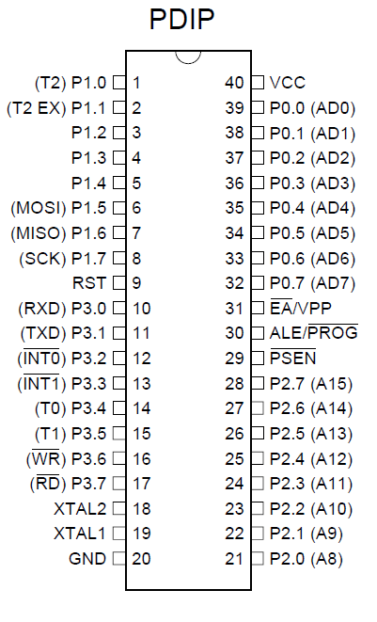
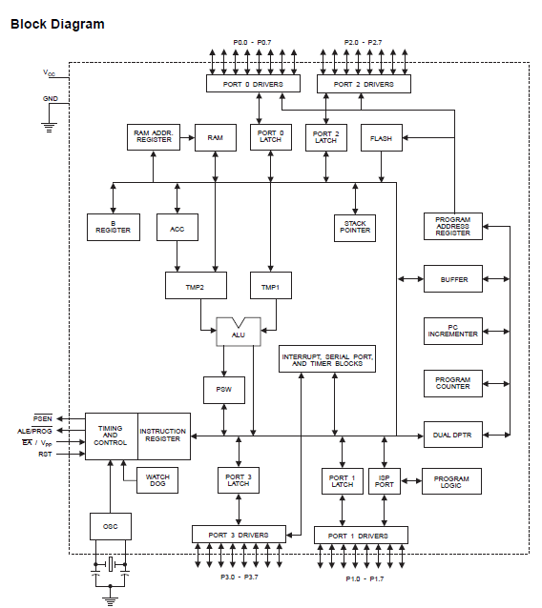

PIN DESCRIPTION

VCC
Supply voltage.

GND
Ground.

Port 0
Port 0 is an 8-bit open drain bidirectional I/O port. As an output port, each pin can sink eight TTL inputs. When 1s are written to port 0 pins, the pins can be used as high impedance inputs. Port 0 can also be configured to be the multiplexed low order address/data bus during accesses to external program and data memory. In this mode, P0 has internal pull-ups. Port 0 also receives the code bytes during Flash programming and outputs the code bytes during program verification. External pull-ups are required during program verification.

Port 1
Port 1 is an 8-bit bidirectional I/O port with internal pull-ups. The Port 1 output buffers can sink/source four TTL inputs. When 1s are written to Port 1 pins, they are pulled high by the internal pull-ups and can be used as inputs. As inputs, Port 1 pins that are externally being pulled low will source current (IIL) because of the internal pull-ups. In addition, P1.0 and P1.1 can be configured to be the timer/counter 2 external count input (P1.0/T2) and the timer/counter 2 trigger input (P1.1/T2EX), respectively, as shown in the following table. Port 1 also receives the low-order address bytes during Flash programming and verification.
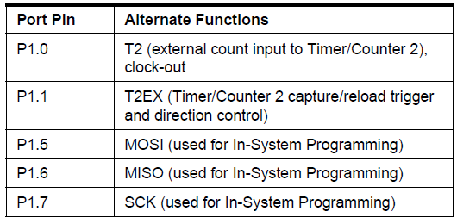
Port 2
Port 2 is an 8-bit bidirectional I/O port with internal pull-ups. The Port 2 output buffers can sink/source four TTL inputs. When 1s are written to Port 2 pins, they are pulled high by the internal pull-ups and can be used as inputs. As inputs, Port 2 pins that are externally being pulled low will source current (IIL) because of the internal pull-ups. Port 2 emits the high-order address byte during fetches from external program memory and during accesses to external data memory that uses 16-bit addresses (MOVX @ DPTR). In this application, Port 2 uses strong internal pull-ups when emitting 1s. During accesses to external data memory that uses 8-bit addresses (MOVX @ RI), Port 2 emits the contents of the P2 Special Function Register. Port 2 also receives the high-order address bits and some control signals during Flash programming and verification.

Port 3
Port 3 is an 8-bit bidirectional I/O port with internal pull-ups. The Port 3 output buffers can sink/source four TTL inputs. When 1s are written to Port 3 pins, they are pulled high by the internal pull-ups and can be used as inputs. As inputs, Port 3 pins that are externally being pulled low will source current (IIL) because of the pull-ups. Port 3 also serves the functions of various special features of the AT89S52, as shown in the following table. Port 3 also receives some control signals for Flash programming and verification.

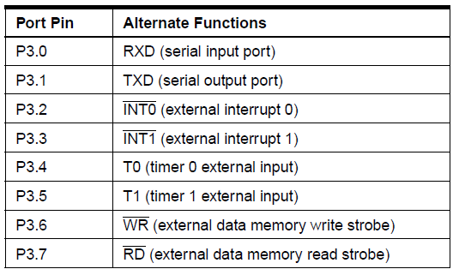

RST
Reset input. A high on this pin for two machine cycles while the oscillator is running resets the device. This pin drives High for 96 oscillator periods after the Watchdog times out. The DISRTO bit in SFR AUXR (address 8EH) can be used to disable this feature. In the default state of bit DISRTO, the RESET HIGH out feature is enabled.
ALE/PROG
Address Latch Enable (ALE) is an output pulse for latching the low byte of the address during accesses to external memory. This pin is also the program pulse input (PROG) during Flash programming. In normal operation, ALE is emitted at a constant rate of 1/6 the oscillator frequency and may be used for external timing or clocking purposes. Note, however, that one ALE pulse is skipped during each access to external data memory. If desired, ALE operation can be disabled by setting bit 0 of SFR location 8EH. With the bit set, ALE is active only during a MOVX or MOVC instruction. Otherwise, the pin is weakly pulled high. Setting the ALE-disable bit has no effect if the microcontroller is in external execution mode.
PSEN
Program Store Enable (PSEN) is the read strobe to external program memory. When the AT89S52 is executing code from external program memory, PSEN is activated twice each machine cycle, except that two PSEN activations are skipped during each access to external data memory.

EA/VPP
External Access Enable. EA must be strapped to GND in order to enable the device to fetch code from external program memory locations starting at 0000H up to FFFFH. Note, however, that if lock bit 1 is programmed, EA will be internally latched on reset.
EA should be strapped to VCC for internal program executions. This pin also receives the 12-volt programming enable voltage (VPP) during Flash programming.

XTAL1
Input to the inverting oscillator amplifier and input to the internal clock operating circuit.

XTAL2
Output from the inverting oscillator amplifier.
XTAL1 and XTAL2 are the input and output, respectively, of an inverting amplifier that can be configured for use as an on-chip oscillator, as shown in Figure. Either a quartz crystal or ceramic resonator may be used. To drive the device from an external clock source, XTAL2 should be left unconnected while XTAL1 is driven, as shown in the below figure. There are no requirements on the duty cycle of the external clock signal, since the input to the internal clocking circuitry is through a divide-by-two flip-flop, but minimum and maximum voltage high and low time specifications must be observed.
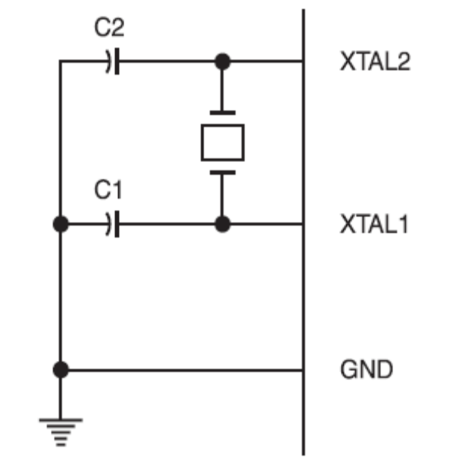
Fig: Oscillator Connections

C1, C2 = 30 pF ± 10 pF for Crystals
= 40 pF ± 10 pF for Ceramic Resonators

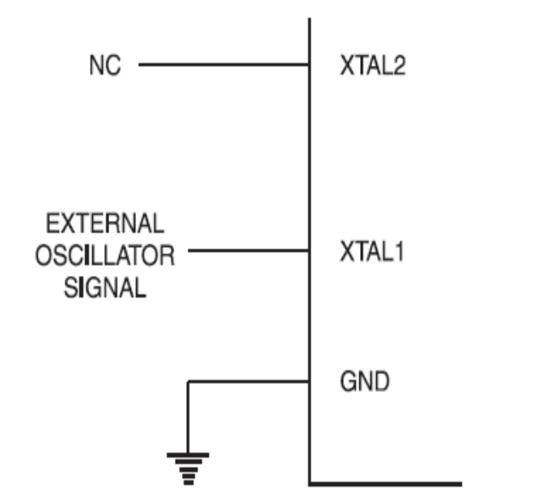
Fig: External Clock Drive Configuration

8052 MICROCONTROLLER MEMORY ORGANIZATION
The microcontroller memory is divided into Program Memory and Data Memory. Program Memory (ROM) is used for permanent saving program being executed, while Data Memory (RAM) is used for temporarily storing and keeping intermediate results and variables. Depending on the model in use (still referring to the whole 8052 microcontroller family) at most a few Kb of ROM and 128 or 256 bytes of RAM can be used. However…
All 8052 microcontrollers have 16-bit addressing bus and can address 64 kb memory. It is neither a mistake nor a big ambition of engineers who were working on basic core development. It is a matter of very clever memory organization which makes these controllers a real “programmers’ tidbit“.

Program Memory :
The oldest models of the 8052 microcontroller family did not have any internal program memory. It was added from outside as a separate chip. These models are recognizable by their label beginning with 803 (for ex. 8031 or 8032). All later models have a few Kbytes ROM embedded, Even though it is enough for writing most of the programs, there are situations when additional memory is necessary. A typical example of it is the use of so called lookup tables. They are used in cases when something is too complicated or when there is no time for solving equations describing some process. The example of it can be totally exotic (an estimate of self-guided rockets’ meeting point) or totally common (measuring of temperature using non-linear thermo element or asynchronous motor speed control). In those cases all needed estimates and approximates are executed in advance and the final results are put in the tables (similar to logarithmic tables).
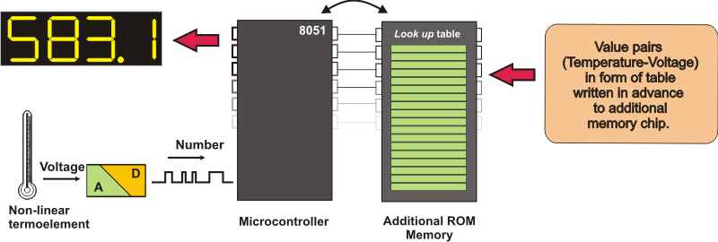
How does the microcontroller handle external memory depend on the pin EA logic state?
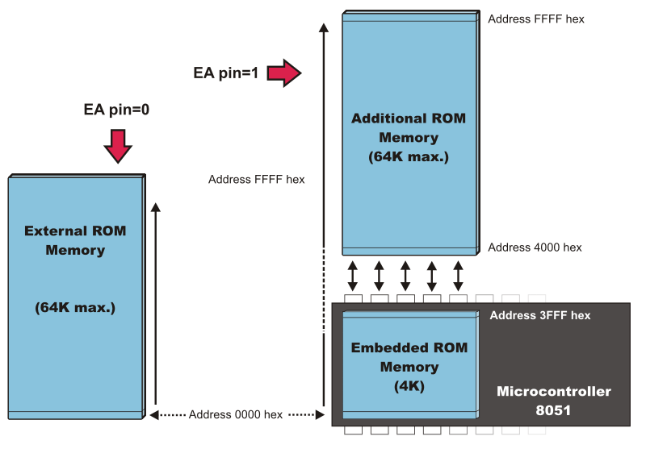
EA=0 In this case, internal program memory is completely ignored, only a program stored in external memory is to be executed.
EA=1 In this case, a program from built-in ROM is to be executed first (to the last location). Afterwards, the execution is continued by reading additional memory.
in both cases, P0 and P2 are not available to the user because they are used for data and address transmission. Besides, the pins ALE and PSEN are used too.

Data Memory :
As already mentioned, Data Memory is used for temporarily storing and keeping data and intermediate results created and used during microcontroller’s operating. Besides, this microcontroller family includes many other registers such as: hardware counters and timers, input/output ports, serial data buffers etc. The previous versions have the total memory size of 256 locations, while for later models this number is incremented by additional 128 available registers. In both cases, these first 256 memory locations (addresses 0-FFh) are the base of the memory. Common to all types of the 8052 microcontrollers. Locations available to the user occupy memory space with addresses from 0 to 7Fh. First 128 registers and this part of RAM is divided in several blocks.
The first block consists of 4 banks each including 8 registers designated as R0 to R7. Prior to access them, a bank containing that register must be selected. Next memory block (in the range of 20h to 2Fh) is bit- addressable, which means that each bit being there has its own address from 0 to 7Fh. Since there are 16 such registers, this block contains in total of 128 bits with separate addresses (The 0th bit of the 20h byte has the bit address 0 and the 7th bit of the 2Fh byte has the bit address 7Fh). The third groups of registers occupy addresses 2Fh-7Fh (in total of 80 locations) and does not have any special purpose or feature.
Additional Memory Block of Data Memory :
In order to satisfy the programmers’ permanent hunger for Data Memory, producers have embedded an additional memory block of 128 locations into the latest versions of the 8052 microcontrollers. Naturally, it’s not so simple…The problem is that electronics performing addressing has 1 byte (8 bits) on disposal and due to that it can reach only the first 256 locations. In order to keep already existing 8-bit architecture and compatibility with other existing models a little trick has been used.

Using trick in this case means that additional memory block shares the same addresses with existing locations intended for the SFRs (80h- FFh). In order to differentiate between these two physically separated memory spaces, different ways of addressing are used. A direct addressing is used for all locations in the SFRs, while the locations from additional RAM are accessible using indirect addressing.

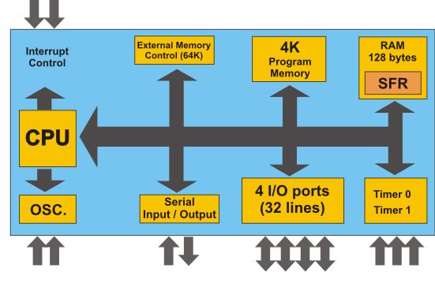
Fig: Microcontroller internal structure

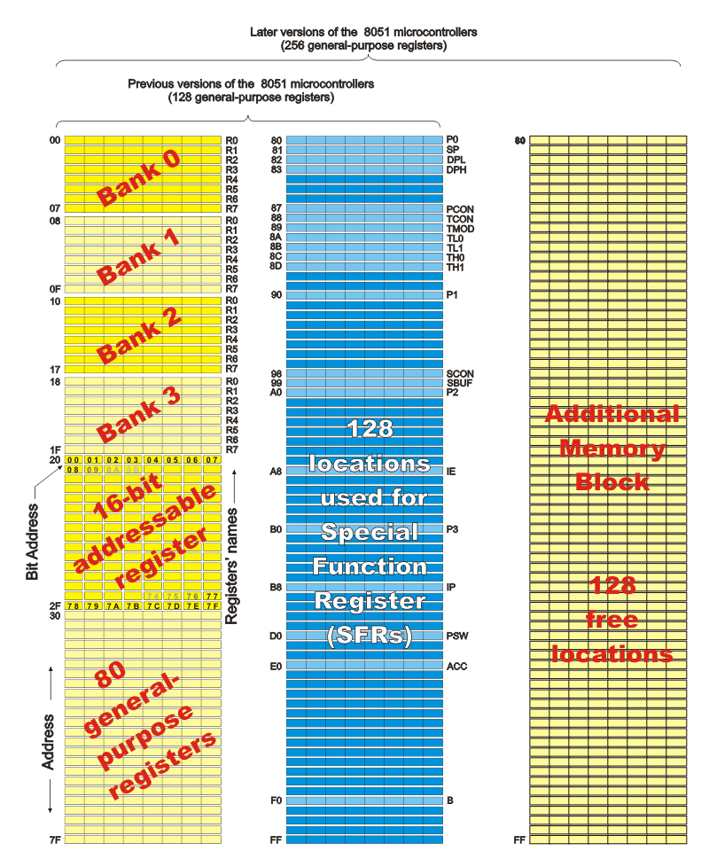
How to extend memory?
In case on-chip memory is not enough, it is possible to add two external memory chips with capacity of 64Kb each. I/O ports P2 and P3 are used for their addressing and data transmission.
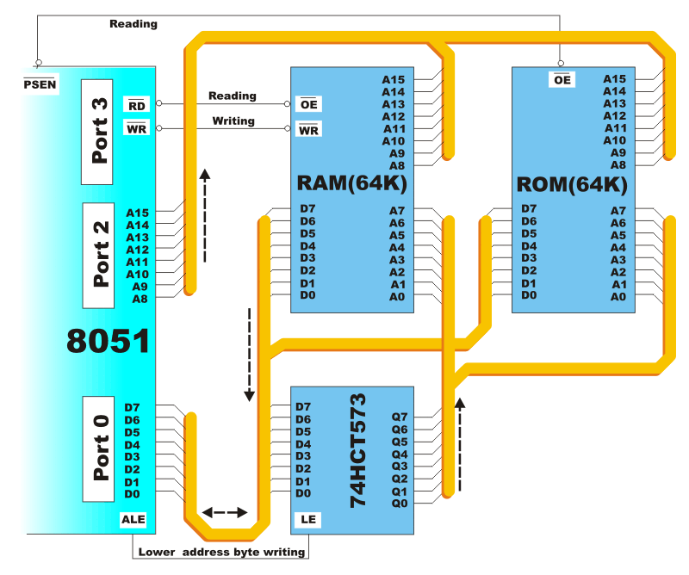
From the users’ perspective, everything functions quite simple if properly connected because the most operations are performed by the microcontroller itself. The 8052 microcontroller has two separate reading signals RD#(P3.7) and PSEN#. The first one is activated byte from external data memory (RAM) should be read, while another one is activated to read byte from external program memory (ROM). These both signals are active at logical zero (0) level. A typical example of such memory extension using special chips for RAM and ROM is shown on the previous picture. It is called Hardward architecture.
Even though the additional memory is rarely used with the latest versions of the microcontrollers, it will be described here in short what happens when memory chips are connected according to the previous scheme. It is important to know that the whole process is performed automatically, i.e. with no intervention in the program.
- When the program during execution encounters the instruction which resides in external memory (ROM), the microcontroller will activate its control output ALE and set the first 8 bits of address (A0-A7) on P0. In this way, IC circuit 74HCT573 which "lets in" the first 8 bits to memory address pins is activated.
- A signal on the pin ALE closes the IC circuit 74HCT573 and immediately afterwards 8 higher bits of address (A8-A15) appear on the port. In this way, a desired location in additional program memory is completely addressed. The only thing left over is to read its content.
- Pins on P0 are configured as inputs, the pin PSEN is activated and the microcontroller reads content from memory chip. The same connections are used both for data and lower address byte.
Similar occurs when it is a needed to read some location from external Data Memory. Now, addressing is performed in the same way, while reading or writing is performed via signals which appear on the control outputs RD or WR.
Addressing
While operating, processor processes data according to the program instructions. Each instruction consists of two parts. One part describes what should be done and another part indicates what to use to do it. This later part can be data (binary number) or address where the data is stored. All 8052 microcontrollers use two ways of addressing depending on which part of memory should be accessed:

Direct Addressing
On direct addressing, a value is obtained from a memory location while the address of that location is specified in instruction. Only after that, the instruction can process data (how depends on the type of instruction: addition, subtraction, copy…). Obviously, a number being changed during operating a variable can reside at that specified address. For example:
Since the address is only one byte in size ( the greatest number is 255), this is how only the first 255 locations in RAM can be accessed in this case the first half of the basic RAM is intended to be used freely, while another half is reserved for the SFRs.
Indirect Addressing
On indirect addressing, a register which contains address of another register is specified in the instruction. A value used in operating process resides in that another register. For example:
Only RAM locations available for use are accessed by indirect addressing (never in the SFRs). For all latest versions of the microcontrollers with additional memory block (those 128 locations in Data Memory), this is the only way of accessing them. Simply, when during operating, the instruction including “@” sign is encountered and if the specified address is higher than 128 (7F hex.), the processor knows that indirect addressing is used and jumps over memory space reserved for the SFRs.
On indirect addressing, the registers R0, R1 or Stack Pointer are used for specifying 8-bit addresses. Since only 8 bits are available, it is possible to access only registers of internal RAM in this way (128 locations in former or 256 locations in latest versions of the microcontrollers). If memory extension in form of additional memory chip is used then the 16-bit DPTR Register (consisting of the registers DPTRL and DPTRH) is used for specifying addresses. In this way it is possible to access any location in the range of 64K.

SFRs (Special Function Registers)
SFRs are a kind of control table used for running and monitoring microcontroller’s operating. Each of these registers, even each bit they include, has its name, address in the scope of RAM and clearly defined purpose ( for example: timer control, interrupt, serial connection etc.). Even though there are 128 free memory locations intended for their storage, the basic core, shared by all types of 8052 controllers, has only 21 such registers. Rest of locations is intensionally left free in order to enable the producers to further improved models keeping at the same time compatibility with the previous versions. It also enables the use of programs written a long time ago for the microcontrollers which are out of production now.

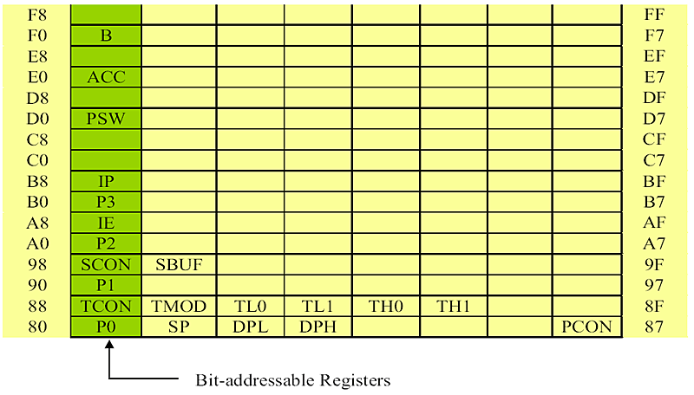
A Register (Accumulator) 
This is a general-purpose register which serves for storing intermediate results during operating. A number (an operand) should be added to the accumulator prior to execute an instruction upon it. Once an arithmetical operation is preformed by the ALU, the result is placed into the accumulator. If a data should be transferred from one register to another, it must go through accumulator. For such universal purpose, this is the most commonly used register that none microcontroller can be imagined without (more than a half 8052 microcontroller's instructions used use the accumulator in some way).

B Register

B register is used during multiply and divide operations which can be performed only upon numbers stored in the A and B registers. All other instructions in the program can use this register as a spare accumulator (A).

During programming, each of registers is called by name so that their exact address is not so important for the user. During compiling into machine code (series of hexadecimal numbers recognized as instructions by the microcontroller), PC will automatically, instead of registers’ name, write necessary addresses into the microcontroller.

R Registers (R0-R7)
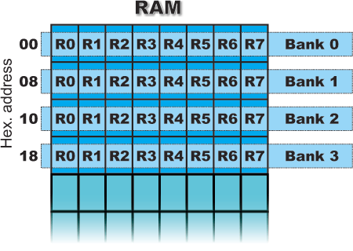
This is a common name for the total 8 general purpose registers (R0, R1, R2 ...R7). Even they are not true SFRs, they deserve to be discussed here because of their purpose. The bank is active when the R registers it includes are in use. Similar to the accumulator, they are used for temporary storing variables and intermediate results. Which of the banks will be active depends on two bits included in the PSW Register. These registers are stored in four banks in the scope of RAM.
Description:
The AT89S52 is a low-voltage, high-performance CMOS 8-bit microcomputer with 4K bytes of Flash programmable memory. The device is manufactured using Atmel’s high-density nonvolatile memory technology and is compatible with the industry-standard MCS-51 instruction set. By combining a versatile 8-bit CPU with Flash on a monolithic chip, the Atmel AT89S52 is a powerful microcomputer, which provides a highly flexible and cost-effective solution to many embedded control applications.
In addition, the AT89S52 is designed with static logic for operation down to zero frequency and supports two software selectable power saving modes. The Idle Mode stops the CPU while allowing the RAM, timer/counters, serial port and interrupt system to continue functioning. The power-down mode saves the RAM contents but freezes the oscillator disabling all other chip functions until the next hardware reset.
Machine cycle for the 8052
The CPU takes a certain number of clock cycles to execute an instruction. In the 8052 family, these clock cycles are referred to as machine cycles. The length of the machine cycle depends on the frequency of the crystal oscillator. The crystal oscillator, along with on-chip circuitry, provides the clock source for the 8052 CPU.
The frequency can vary from 4 MHz to 30 MHz, depending upon the chip rating and manufacturer. But the exact frequency of 11.0592 MHz crystal oscillator is used to make the 8052 based system compatible with the serial port of the IBM PC.
In the original version of 8052, one machine cycle lasts 12 oscillator periods. Therefore, to calculate the machine cycle for the 8052, the calculation is made as 1/12 of the crystal frequency and its inverse is taken.

Introduction to Embedded Systems
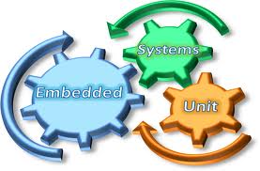

INTRODUCTION TO EMBEDDED SYSTEMS:
An embedded system can be defined as a computing device that does a specific focused job. Appliances such as the air-conditioner, VCD player, DVD player, printer, fax machine, mobile phone etc. are examples of embedded systems. Each of these appliances will have a processor and special hardware to meet the specific requirement of the application along with the embedded software that is executed by the processor for meeting that specific requirement. The embedded software is also called “firm ware”. The desktop/laptop computer is a general purpose computer. You can use it for a variety of applications such as playing games, word processing, accounting, software development and so on. In contrast, the software in the embedded systems is always fixed listed below:
Embedded systems do a very specific task, they cannot be programmed to do different things. Embedded systems have very limited resources, particularly the memory. Generally, they do not have secondary storage devices such as the CDROM or the floppy disk. Embedded systems have to work against some deadlines. A specific job has to be completed within a specific time. In some embedded systems, called real-time systems, the deadlines are stringent. Missing a deadline may cause a catastrophe-loss of life or damage to property. Embedded systems are constrained for power. As many embedded systems operate through a battery, the power consumption has to be very low.
· Some embedded systems have to operate in extreme environmental conditions such as very high temperatures and humidity.
Application Areas:
Nearly 99 per cent of the processors manufactured end up in embedded systems. The embedded system market is one of the highest growth areas as these systems are used in very market segment- consumer electronics, office automation, industrial automation, biomedical engineering, wireless communication,data communication, telecommunications, transportation, military and so on.

Consumer appliances: At home we use a number of embedded systems which include digital camera, digital diary, DVD player, electronic toys, microwave oven, remote controls for TV and air-conditioner, VCO player, video game consoles, video recorders etc. Today’s high-tech car has about 20 embedded systems for transmission control, engine spark control, air-conditioning, navigation etc. Even wristwatches are now becoming embedded systems. The palmtops are powerful embedded systems using which we can carry out many general-purpose tasks such as playing games and word processing.
Office automation: The office automation products using em embedded systems are copying machine, fax machine, key telephone, modem, printer, scanner etc.
Industrial automation: Today a lot of industries use embedded systems for process control. These include pharmaceutical, cement, sugar, oil exploration, nuclear energy, electricity generation and transmission. The embedded systems for industrial use are designed to carry out specific tasks such as monitoring the temperature, pressure, humidity, voltage, current etc., and then take appropriate action based on the monitored levels to control other devices or to send information to a centralized monitoring station. In hazardous industrial environment, where human presence has to be avoided, robots are used, which are programmed to do specific jobs. The robots are now becoming very powerful and carry out many interesting and complicated tasks such as hardware assembly.
Medical electronics: Almost every medical equipment in the hospital is an embedded system. These equipments include diagnostic aids such as ECG, EEG, blood pressure measuring devices, X-ray scanners; equipment used in blood analysis, radiation, colonscopy, endoscopy etc. Developments in medical electronics have paved way for more accurate diagnosis of diseases.
Computer networking: Computer networking products such as bridges, routers, Integrated Services Digital Networks (ISDN), Asynchronous Transfer Mode (ATM), X.25 and frame relay switches are embedded systems which implement the necessary data communication protocols. For example, a router interconnects two networks. The two networks may be running different protocol stacks. The router’s function is to obtain the data packets from incoming pores, analyze the packets and send them towards the destination after doing necessary protocol conversion. Most networking equipments, other than the end systems (desktop computers) we use to access the networks, are embedded systems.
Telecommunications: In the field of telecommunications, the embedded systems can be categorized as subscriber terminals and network equipment. The subscriber terminals such as key telephones, ISDN phones, terminal adapters, web cameras are embedded systems. The network equipment includes multiplexers, multiple access systems, Packet Assemblers Dissemblers (PADs), sate11ite modems etc. IP phone, IP gateway, IP gatekeeper etc. are the latest embedded systems that provide very low-cost voice communication over the Internet.
Wireless technologies: Advances in mobile communications are paving way for many interesting applications using embedded systems. The mobile phone is one of the marvels of the last decade of the 20’h century. It is a very powerful embedded system that provides voice communication while we are on the move. The Personal Digital Assistants and the palmtops can now be used to access multimedia services over the Internet. Mobile communication infrastructure such as base station controllers, mobile switching centers are also powerful embedded systems.
Insemination: Testing and measurement are the fundamental requirements in all scientific and engineering activities. The measuring equipment we use in laboratories to measure parameters such as weight, temperature, pressure, humidity, voltage, current etc. are all embedded systems. Test equipment such as oscilloscope, spectrum analyzer, logic analyzer, protocol analyzer, radio communication test set etc. are embedded systems built around powerful processors. Thank to miniaturization, the test and measuring equipment are now becoming portable facilitating easy testing and measurement in the field by field-personnel.
Security: Security of persons and information has always been a major issue. We need to protect our homes and offices; and also the information we transmit and store. Developing embedded systems for security applications is one of the most lucrative businesses nowadays. Security devices at homes, offices, airports etc. for authentication and verification are embedded systems. Encryption devices are nearly 99 per cent of
the processors that are manufactured end up in~ embedded systems. Embedded systems find applications in . every industrial segment- consumer electronics, transportation, avionics, biomedical engineering, manufacturing, process control and industrial automation, data communication, telecommunication, defense, security etc. Used to encrypt the data/voice being transmitted on communication links such as telephone lines. Biometric systems using fingerprint and face recognition are now being extensively used for user authentication in banking applications as well as for access control in high security buildings.
Finance: Financial dealing through cash and cheques are now slowly paving way for transactions using smart cards and ATM (Automatic Teller Machine, also expanded as Any Time Money) machines. Smart card, of the size of a credit card, has a small micro-controller and memory; and it interacts with the smart card reader! ATM machine and acts as an electronic wallet. Smart card technology has the capability of ushering in a cashless society. Well, the list goes on. It is no exaggeration to say that eyes wherever you go, you can see, or at least feel, the work of an embedded system!
Overview of Embedded System Architecture:
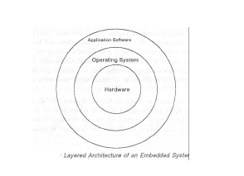
Every embedded system consists of custom-built hardware built around a Central Processing Unit (CPU). This hardware also contains memory chips onto which the software is loaded. The software residing on the memory chip is also called the ‘firmware’. The embedded system architecture can be represented as a layered architecture as shown in Fig.
The operating system runs above the hardware, and the application software runs above the operating system. The same architecture is applicable to any computer including a desktop computer. However, there are significant differences. It is not compulsory to have an operating system in every embedded system. For small appliances such as remote control units, air conditioners, toys etc., there is no need for an operating system and you can write only the software specific to that application. For applications involving complex processing, it is advisable to have an operating system. In such a case, you need to integrate the application software with the operating system and then transfer the entire software on to the memory chip. Once the software is transferred to the memory chip, the software will continue to run for a long time you don’t need to reload new software.
Now, let us see the details of the various building blocks of the hardware of an embedded system. As shown in Fig. the building blocks are;
· Central Processing Unit (CPU)
· Memory (Read-only Memory and Random Access Memory)
· Input Devices
· Output devices
· Communication interfaces
· Application-specific circuitry
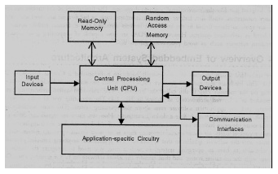

Central Processing Unit (CPU):
The Central Processing Unit (processor, in short) can be any of the following: microcontroller, microprocessor or Digital Signal Processor (DSP). A micro-controller is a low-cost processor. Its main attraction is that on the chip itself, there will be many other components such as memory, serial communication interface, analog-to digital converter etc. So, for small applications, a micro-controller is the best choice as the number of external components required will be very less. On the other hand, microprocessors are more powerful, but you need to use many external components with them. D5P is used mainly for applications in which signal processing is involved such as audio and video processing.
Memory:
The memory is categorized as Random Access 11emory (RAM) and Read Only Memory (ROM). The contents of the RAM will be erased if power is switched off to the chip, whereas ROM retains the contents even if the power is switched off. So, the firmware is stored in the ROM. When power is switched on, the processor reads the ROM; the program is program is executed.

Input devices:
Unlike the desktops, the input devices to an embedded system have very limited capability. There will be no keyboard or a mouse, and hence interacting with the embedded system is no easy task. Many embedded systems will have a small keypad-you press one key to give a specific command. A keypad may be used to input only the digits. Many embedded systems used in process control do not have any input device for user interaction; they take inputs from sensors or transducers 1’fnd produce electrical signals that are in turn fed to other systems.

Output devices:
The output devices of the embedded systems also have very limited capability. Some embedded systems will have a few Light Emitting Diodes (LEDs) to indicate the health status of the system modules, or for visual indication of alarms. A small Liquid Crystal Display (LCD) may also be used to display some important parameters.

Communication interfaces:
The embedded systems may need to, interact with other embedded systems at they may have to transmit data to a desktop. To facilitate this, the embedded systems are provided with one or a few communication interfaces such as RS232, RS422, RS485, Universal Serial Bus (USB), IEEE 1394, Ethernet etc.

Application-specific circuitry:
Sensors, transducers, special processing and control circuitry may be required fat an embedded system, depending on its application. This circuitry interacts with the processor to carry out the necessary work. The entire hardware has to be given power supply either through the 230 volts main supply or through a battery. The hardware has to design in such a way that the power consumption is minimized.

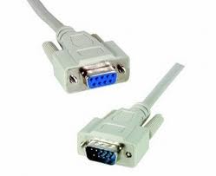

Introduction to Serial Communication MAX232

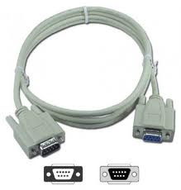

Introduction:
UART (Universal Asynchronous Receiver Transmitter) or USART (Universal Synchronous Asynchronous Receiver Transmitter) are one of the basic interface which you will find in almost all the controllers available in the market till date. This interface provides a cost effective simple and reliable communication between one controller to another controller or between a controller and PC.
►RS-232Basics:
RS-232 (Recommended Standard 232) is a standard for serial binary data signals connecting between a DTE (Data terminal equipment) and a DCE (Data Circuit-terminating Equipment).
Voltage Levels:
The RS-232 standard defines the voltage levels that correspond to logical one and logical zero levels. Valid signals are plus or minus 3 to 25 volts. The range near zero volts is not a valid RS-232 level; logic one is defined as a negative voltage, the signal condition is called marking, and has the functional significance of OFF. Logic zero is positive, the signal condition is spacing, and has the function ON.
So a Logic Zero represented as +3V to +25V and Logic One represented as -3V to -25V.
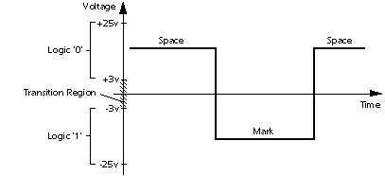
►RS-232 Level Converters
Usually all the digial ICs works on TTL or CMOS voltage levels which cannot be used to communicate over RS-232 protocol. So a voltage or level converter is needed which can convert TTL to RS232 and RS232 to TTL voltage levels.
The most commonly used RS-232 level converter is MAX232. This IC includes charge pump which can generate RS232 voltage levels (-10V and +10V) from 5V power supply. It also includes two receiver and two transmitters and is capable of full-duplex UART/USART communication.
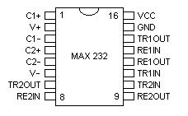
Fig A. - MAX232 Pin Description
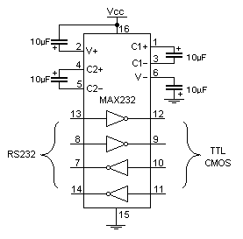
Fig B. - MAX232 Typical Connection Circuit
►MAX232InterfacingwithMicrocontrollers:
To communicate over UART or USART, we just need three basic signals which are namely, RXD (receive), TXD (transmit), GND (common ground). So to interface MAX232 with any microcontroller (AVR, ARM, 8051, PIC etc..) we just need the basic signals. A simple schematic diagram of connections between a microcontroller and MAX232 is shown below
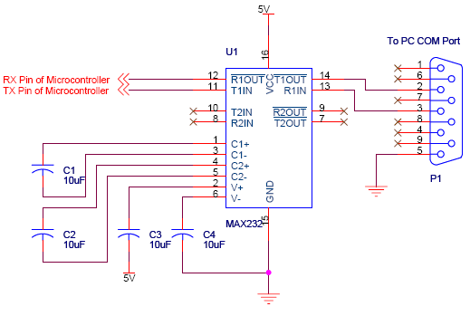
In the next part of this tutorial we will discuss programming microcontroller to communicate over UART and software implementation of half duples UART.

Introduction:
UART (Universal Asynchronous Receiver Transmitter) or USART (Universal Synchronous Asynchronous Receiver Transmitter) are one of the basic interface which you will find in almost all the controllers available in the market till date. This interface provides a cost effective simple and reliable communication between one controller to another controller or between a controller and PC.
►RS-232Basics:
RS-232 (Recommended Standard 232) is a standard for serial binary data signals connecting between a DTE (Data terminal equipment) and a DCE (Data Circuit-terminating Equipment).
Voltage Levels:
The RS-232 standard defines the voltage levels that correspond to logical one and logical zero levels. Valid signals are plus or minus 3 to 25 volts. The range near zero volts is not a valid RS-232 level; logic one is defined as a negative voltage, the signal condition is called marking, and has the functional significance of OFF. Logic zero is positive, the signal condition is spacing, and has the function ON.
So a Logic Zero represented as +3V to +25V and Logic One represented as -3V to -25V.
►RS-232 Level Converters
Usually all the digial ICs works on TTL or CMOS voltage levels which cannot be used to communicate over RS-232 protocol. So a voltage or level converter is needed which can convert TTL to RS232 and RS232 to TTL voltage levels.
The most commonly used RS-232 level converter is MAX232. This IC includes charge pump which can generate RS232 voltage levels (-10V and +10V) from 5V power supply. It also includes two receiver and two transmitters and is capable of full-duplex UART/USART communication.
Fig A. - MAX232 Pin Description
Fig B. - MAX232 Typical Connection Circuit
►MAX232InterfacingwithMicrocontrollers:
To communicate over UART or USART, we just need three basic signals which are namely, RXD (receive), TXD (transmit), GND (common ground). So to interface MAX232 with any microcontroller (AVR, ARM, 8051, PIC etc..) we just need the basic signals. A simple schematic diagram of connections between a microcontroller and MAX232 is shown below
In the next part of this tutorial we will discuss programming microcontroller to communicate over UART and software implementation of half duples UART.

Introduction to RF Module

Rf communication:
RF communication works by creating electromagnetic waves at a source and being able to pick up those electromagnetic waves at a particular destination. These electromagnetic waves travel through the air at near the speed of light. The wavelength of an electromagnetic signal is inversely proportional to the frequency; the higher the frequency, the shorter the wavelength.
Frequency is measured in Hertz (cycles per second) and radio frequencies are measured in kilohertz (KHz or thousands of cycles per second), megahertz (MHz or millions of cycles per second) and gigahertz (GHz or billions of cycles per second). Higher frequencies result in shorter wavelengths. The wavelength for a 900 MHz device is longer than that of a 2.4 GHz device.
In general, signals with longer wavelengths travel a greater distance and penetrate through, and around objects better than signals with shorter wavelengths.
RF communication system work
Imagine an RF transmitter wiggling an electron in one location. This wiggling electron causes a ripple effect, somewhat akin to dropping a pebble in a pond. The effect is an electromagnetic (EM) wave that travels out from the initial location resulting in electrons wiggling in remote locations. An RF receiver can detect this remote electron wiggling.
The RF communication system then utilizes this phenomenon by wiggling electrons in a specific pattern to represent information. The receiver can make this same information available at a remote location; communicating with no wires.
In most wireless systems, a designer has two overriding constraints: it must operate over a certain distance (range) and transfer a certain amount of information within a time frame (data rate). Then the economics of the system must work out (price) along with acquiring government agency approvals (regulations and licensing).

RF communications and data rate
Data rates are usually dictated by the system - how much data must be transferred and how often does the transfer need to take place. Lower data rates, allow the radio module to have better receive sensitivity and thus more range. In the XStream modules the 9600 baud module has 3dB more sensitivity than the 19200 baud module. This means about 30% more distance in line-of-sight conditions. Higher data rates allow the communication to take place in less time, potentially using less power to transmit.
Widely used, including Bluetooth, Radios, Cell phones, Satellite etc
Wide range, from few meters to millions of kilometers (Can be used to control Robots in Mars)
Does not requires two devices to be in line of sight.
Can cross many obstacles
Circuits can be complicated and costly.
In this tutorial we will learn how to practically implement a wireless link between two MCUs. This link will be used to send and receive digital data. We will create a Radio Frequency link. However as I said the RF circuits are little complicated so we will use readymade RF Modules. These are easily available and low cost.

RF Module
A RF Module is a small circuit pre built and tested. They comes in Pair. One is RX or the receiver and other is a TX or Transmitter. The one we will be using is a low cost module of about Rs. 300 (US$ 6.00) per pair in India. They have reasonable range and works very good. Typical data rate is 1000 bits per seconds. You can buy them from the following links
- RX
- TX
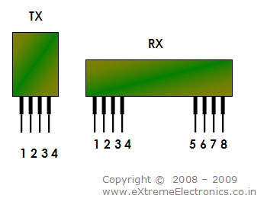

RF Modules
As you can see they have very low pin count. This is because they are highly modular in design. The PINs are
- TX
  - Antenna
  - Vcc (Positive Supply)
  - DATA (Data Input)
  - GND
- RX
  - Antenna
  - GND
  - GND
  - Vcc (Positive Supply)
  - Vcc (Positive Supply)
  - DATA
  - DATA
  - GND
So you just need to apply power and fit an antenna and its ready to work. But the real "TRICK" is in sending and receiving data. And due to this many beginner fail to use them the first time (same thing happened with me too !). So I will revel the "TRICK" and give you a working example so that you can use these modules for many projects in the future.
Rf receiver:

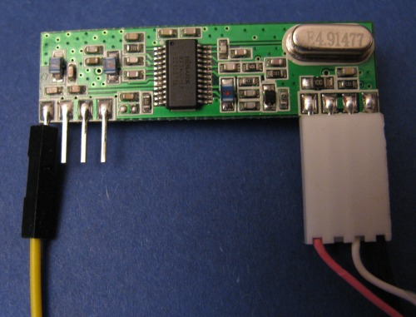
Only four wires are required, i have used a audio cable from a cd drive which i rewired to accept the cables (neat).
Yellow is the Antenna - approx 30cm long (other end connected to thin air)
Red is connected to 5 Volts
White is the Received data (in my case connected to pin 23 on the mega - can be easily assigned to another pin)
Black is Ground (it has three separate ground pins all connected together!!!!!!)
Connecting a Receiver Module
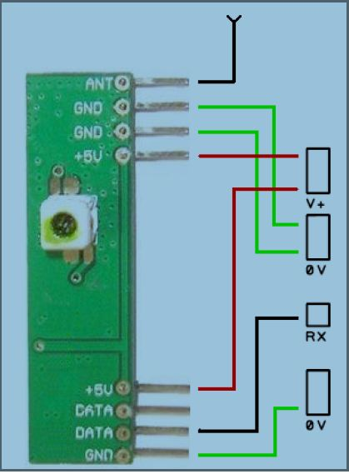
The following shows a typical connection of a receiver module to the receiver board connection points. The receiver module pictured is as supplied in part RFA001. In this example the pin connections are printed on the receiver module PCB; if they are not you will have to consult the manufacturer’s datasheet to determine the pinout. Note that some receiver modules may have more than one DATA output. These may be ‘digital’ and ‘analogue’ and it will be necessary to determine which to connect to the
receiver board. Some published circuits using the receiver module chosen may show both DATA outputs connected together; this is not always correct or most appropriate and some experimentation may be required to determine which DATA output to use. With the module supplied in part RFA001 only use one connection as shown. The receiver module may be soldered directly to the receiver board ‘prototyping area’ or suitable sockets may be soldered into which the module is then inserted. Connections between module or socket and receiver boardconnection points are made with wire links.
RWS-434: The receiver also operates at 433.92MHz, and has a sensitivity of 3uV. The RWS-434 receiver operates from 4.5 to 5.5 volts-DC, and has both linear and digital outputs.
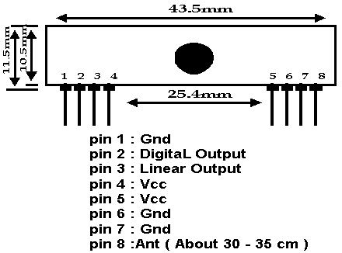
RWS-434 Pin Diagram
Note: For maximum range, the recommended antenna should be approximately 35cm long. To convert from centimeters to inches -- multiply by 0.3937. For 35cm, the length in inches will be approximately 35cm x 0.3937 = 13.7795 inches long. We tested these modules using a 14", solid, 24 gauge hobby type wire, and reached a range of over 400 foot. Your results may vary depending on your surroundings.

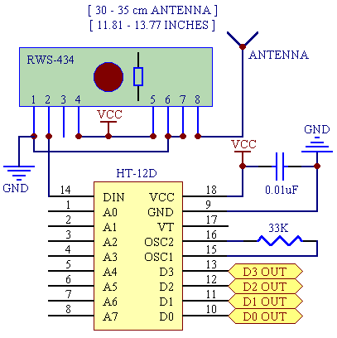
The example above shows the receiver section using the HT-12D decoder IC for a 4-bit RF remote control system. The transmitter and receiver can also use the Holtek 8-bit HT-640/HT-648L remote control encoder/decoder combination for an 8-bit RF remote control system. Here are the schematics for an 8-bit RF remote control system:

RF transmitter:
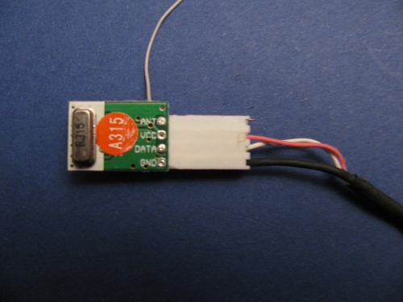
this also has 4 wires and the same trick with the cd audio socket to make neat connection.
Black connected to Ground White is the transmit data cable connected to pin 3 on the Arduino (however this is easy to re-assign to suit your needs) Red is the power supply connected to 5 Volt pin on Arduino (actually you can apply anywhere between 2 Volts and 12 Volts - the higher the voltage the stronger the RF signal)

Transmitter Module Connections

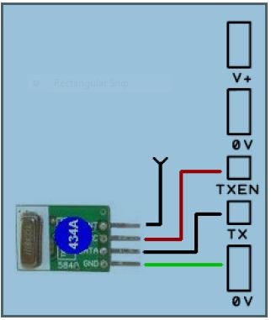
The following shows a typical connection of a transmitter module to the transmitter board connection points. The transmitter module pictured is as supplied in part RFA001. On this transmitter the pin connections are physically printed on the transmitter
module PCB; if the pins on your unit are not labelled you will have to consult the manufacturer’s datasheet to determine the pin-out. Note that the VCC for the transmitter module is connected to TXEN rather than V+. This means the transmitter module will only be powered when it needs to be and is recommended practice. The transmitter module may be soldered directly to the transmitter board ‘prototyping area’ or suitable sockets may be soldered into which the module is then inserted. Connections between module or socket and transmitter board connection points are made with wire links.
The TWS-434 and RWS-434 are extremely small, and are excellent for applications requiring short-range RF remote controls. The transmitter module is only 1/3 the size of a standard postage stamp, and can easily be placed inside a small plastic enclosure.
TWS-434: The transmitter output is up to 8mW at 433.92MHz with a range of approximately 400 foot (open area) outdoors. Indoors, the range is approximately 200 foot, and will go through most walls.....
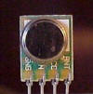
TWS-434A
The TWS-434 transmitter accepts digital inputs, can operate from 1.5 to 12 Volts-DC, and makes building a miniature hand-held RF transmitter very easy. The TWS-434 is approximately the size of a standard postage stamp.
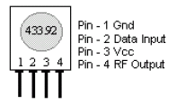
TWS-434 Pin Diagram

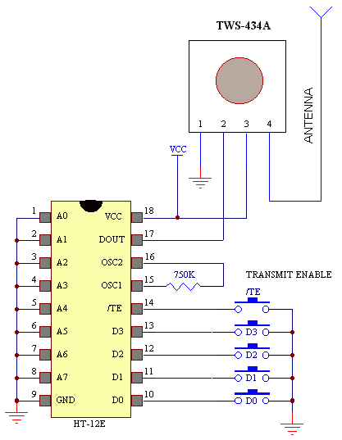
Sample Transmitter Application Circuit

ENCODERS (HT12E)
The HT12E encoder is a 18 pin DIP IC. The 2¹² encoders are a series of CMOS LSIs for remote control system applications.
Features
- Operating voltage
- 2.4V~12V for the HT12E
- Low power and high noise immunity CMOS technology
- Low standby current: 0.1_A (type.) at VDD=5V
- Minimum transmission word
- Four words for the HT12E
- Built-in oscillator needs only 5% resistor
- Data code has positive polarity
- Minimal external components
- Pair with Holtek’s 2¹² series of decoders
- 18-pin DIP, 20-pin SOP package
Applications
- Burglar alarm system
- Smoke and fire alarm system
- Garage door controllers
- Car door controllers
- Car alarm system
- Security system
- Cordless telephones
- Other remote control systems

General Description
They are capable of encoding information which consists of N address bits and 12_N data bits. Each address/data input can be set to one of the two logic states. The programmed addresses/ data are transmitted together with the header bits via an RF or an infrared transmission medium upon receipt of a trigger signal. The capability to select a TE trigger on the HT12E or a DATA trigger on the HT12E further enhances the application flexibility of the 2¹² series of encoders.
Pin Diagram of HT12E

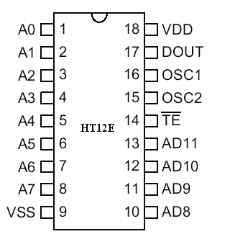

Pin Diagram of HT12E

Pin Description of HT12E

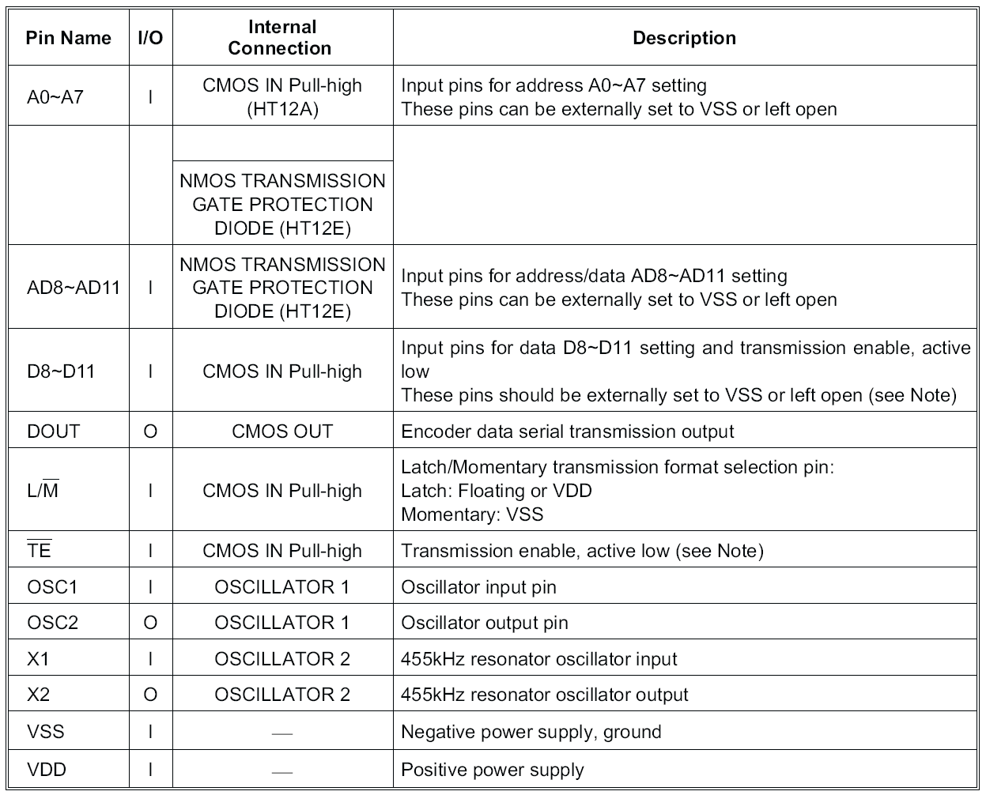

Pin Description of HT12E

DECODERS (HT12D)
The HT12D decoder is a 18 pin DIP IC. The 2¹² decoders are a series of CMOS Large Scale Integrations for remote control system applications. They are paired with Holtek’s 2¹² series of encoders.

Features

- Operating voltage: 2.4V~12V
- Low power and high noise immunity CMOS technology
- Low standby current
- Capable of decoding 12 bits of information
- Binary address setting
- Received codes are checked 3 times
- Address/Data number combination
- HT12D: 8 address bits and 4 data bits
- Built-in oscillator needs only 5% resistor
- Valid transmission indicator
- Easy interface with an RF or an infrared transmission medium
- Minimal external components
- Pair with Holtek’s 2¹² series of encoders

General Description
A pair of encoder/decoder with the same number of addresses and data format should be chosen for proper operation. The decoders receive serial addresses and data from a programmed 2¹² series of encoders that are transmitted by a carrier using an RF or an IR transmission medium. They compare the serial input data three times continuously with their local addresses. If no error or unmatched codes are found, the input data codes are decoded and then transferred to the output pins.

The VT pin also goes high to indicate a valid transmission. The 2¹² series of decoders are capable of decoding information that consists of N bits of address and 12_N bits of data. Of this series, the HT12D is arranged to provide 8 address bits and 4 data bits.
Pin Diagram of HT12D

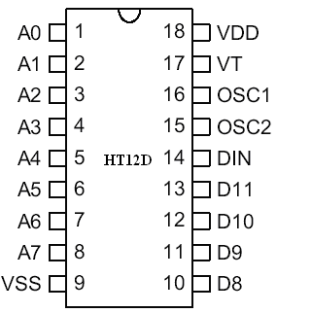

Pin Diagram of HT12D

Pin Description of HT12D

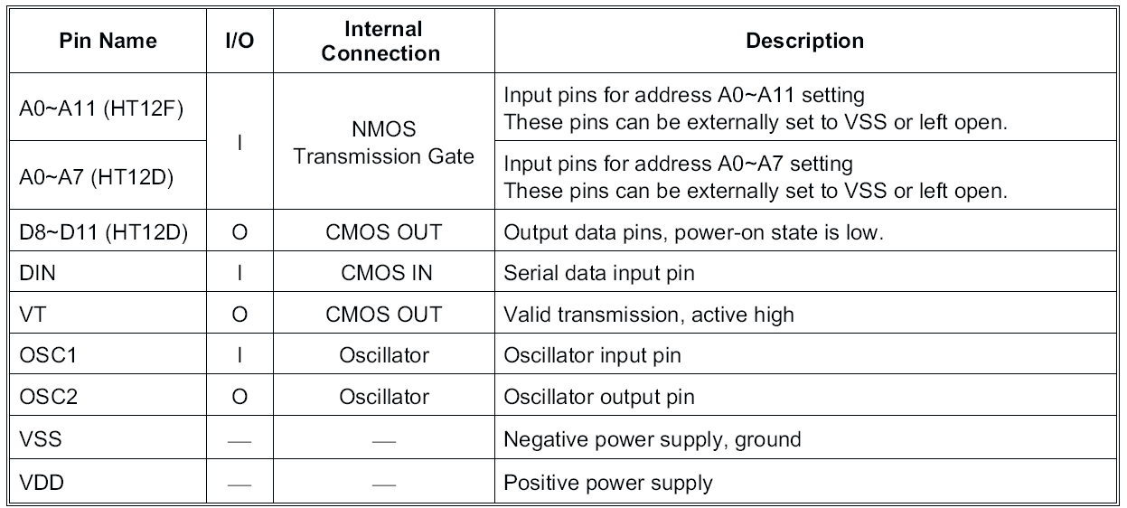

RF

Radio frequency (RF) is a frequency or rate of oscillation within the range of about 3 Hz to 300 GHz. This range corresponds to frequency of alternating current electrical signals used to produce and detect radio waves. Since most of this range is beyond the vibration rate that most mechanical systems can respond to, RF usually refers to oscillations in electrical circuits or electromagnetic radiation

THE NEED FOR RF
Radio frequency is a frequency or rate of oscillation within the range of about 3 Hz to 300 GHz. This range corresponds to frequency of alternating current electrical signals used to produce and detect radio waves Since most of this range is beyond the vibration rate that most mechanical systems can respond to, RF usually refers to oscillations in electrical circuits. RF is widely used because it does not require any line of sight, less distortions and no interference

PROPERTIES OF RF:
Electrical currents that oscillate at RF have special properties not shared by direct current signals. One such property is the ease with which it can ionize air to create a conductive path through air. This property is exploited by 'high frequency' units used in electric arc welding. Another special property is an electromagnetic force that drives the RF current to the surface of conductors, known as the skin effect. Another property is the ability to appear to flow through paths that contain insulating material, like the dielectric insulator of a capacitor. The degree of effect of these properties depends on the frequency of the signals.

BRIEF DESCRIPTION OF RF:

Radio frequency (abbreviated RF) is a term that refers to alternating current (AC) having characteristics such that, if the current is input to an antenna, an electromagnetic (EM) field is generated suitable for wireless broadcasting and/or communications. These frequencies cover a significant portion of the electromagnetic radiation spectrum, extending from nine kilohertz (9 kHz),the lowest allocated wireless communications frequency (it's within the range of human hearing), to thousands of gigahertz(GHz).
When an RF current is supplied to an antenna, it gives rise to an electromagnetic field that propagates through space. This field is sometimes called an RF field; in less technical jargon it is a "radio wave." Any RF field has a wavelength that is inversely proportional to the frequency. In the atmosphere or in outer space, if f is the frequency in megahertz and sis the wavelength in meters, then
s = 300/f
The frequency of an RF signal is inversely proportional to the wavelength
of the EM field to which it corresponds. At 9 kHz, the free-space wavelength is approximately 33 kilometers (km) or 21 miles (mi). At the highest radio frequencies, the EM wavelengths measure approximately one millimeter (1 mm). As the frequency is increased beyond that of the RF spectrum, EM energy takes the form of infrared (IR), visible, ultraviolet (UV), X rays, and gamma rays.
Many types of wireless devices make use of RF fields. Cordless and cellular telephone, radio and television broadcast stations, satellite communications systems, and two-way radio services all operate in the RF spectrum. Some wireless devices operate at IR or visible-light frequencies, whose electromagnetic wavelengths are shorter than those of RF fields. Examples include most television-set remote-control boxes Some cordless computer keyboards and mice, and a few wireless hi-fi stereo headsets.
The RF spectrum is divided into several ranges, or bands. With the exception of the lowest-frequency segment, each band represents an increase of frequency corresponding to an order of magnitude (power of 10). The table depicts the eight bands in the RF spectrum, showing frequency and bandwidth ranges. The SHF and EHF bands are often referred to as the microwave spectrum.

WHY DO WE GO FOR RF COMMUNICATION

RF Advantages:
- No line of sight is needed.
- Not blocked by common materials: It can penetrate most solids and pass through walls.
- Longer range.
- It is not sensitive to the light.
- It is not much sensitive to the environmental changes and weather conditions.

RF RECEIVER STR-433 MHz:

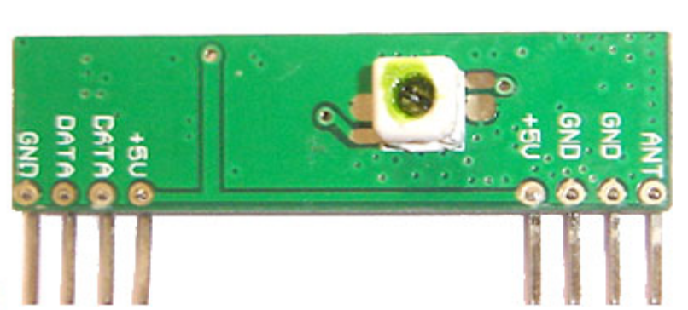

The data is received by the RF receiver from the antenna pin and this data is available on the data pins. Two Data pins are provided in the receiver module. Thus, this data can be used for further applications
.
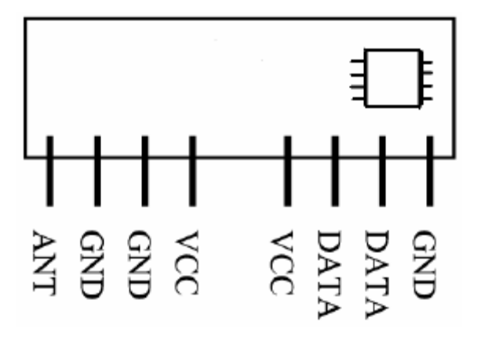
PINOUT:in Name Description
ANT
Antenna input.
GND
Receiver Ground. Connect to ground plane.

VCC (5V)
VCC pins are electrically connected and provide operating voltage for the receiver. VCC can be applied to either or both. VCC should be bypassed with a .1μF ceramic capacitor. Noise on the power supply will degrade receiver sensitivity.
DATA
Digital data output.
This output is capable of driving one TTL or CMOS load. It is a CMOS compatible output.

Introduction to Motor Driver L293D

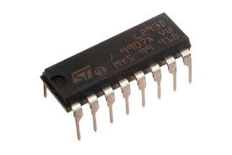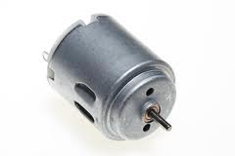

L293DMotor Driver
Introduction:
One of the first realizations in robotics is that making something move isn’t an easy task. You simply can’t take a “brain” circuit and connect it to a motor and expect anything to happen. The motor will simply say “HAH!” at the puny output signal from the brains, and stay stationary. What the brain needs is an enforcer. Muscle. Something to convince the motor to do things the way the brains want it to be done.

There are many ways to strengthen (”buffer”) a signal so it’s strong enough to drive a large load like a motor. Transistor H- bridges circuit, buffer chips, and dedicated motor driving chips are all suitable candidates, with their own benefits and limitations.

For our ‘Secret’ motor driver, we wanted something that would take standard TTL (well, CMOS too) inputs and make a standard servo our slave. You see, standard servos use a “Pulse Width Modulated” (”PWM”) signal to tell a servo where to rotate to. PWM works by sending a rapid train of high/low signals to the servo’s regular driver brains, and depending on how different the high signal is from the low signal, the servo moves to the according position. PWM is great if you don’t want to rotate much more than 180°, which is fine for actuators, but not for driving wheels.

With our ‘Secret’ motor driver and a bit of servo hacking, we’re going to lobotimize and turn a standard servo into something more useful - a small, compact, powerful gear motor! It’ll be something you can use very simple input signals to control it’s rotation. We’ll even throw in a 5V regulator hack if you want to clamp the voltage right at the servo. Or, modify it for use on a breadboard, which will make good use of the driver’s indicator LEDs to show direction of rotation.

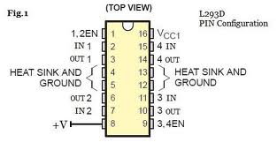
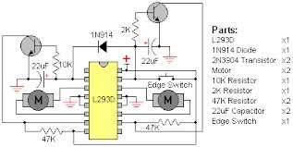

Features

• Single Supply Operation: 2V to 36V
• Dual Supply Operation: ±1V to ±18V
• Allow Comparison of Voltages Near Ground Potential
• Low Current Drain 800μA Typ.
• Compatible with all Forms of Logic
• Low Input Bias Current 25nA Typ.
• Low Input Offset Current ±5nA Typ.
• Low Offset Voltage ±1mV Typ.
Description:
These devices consist of two independent voltage comparators that are designed to operate from a single power supply over a wide range of voltages. Operation from dual supplies also is possible as long as the difference between the two supplies is 2 V to 36 V, and VCC is at least 1.5 V more positive than the input common-mode voltage. Current drain is independent of the supply voltage. The outputs can be connected to other open-collector outputs to achieve wired-AND relationships. The LM193 is characterized for operation from –55°C to 125°C. The LM293 and LM293A are characterized for operation from –25°C to 85°C. The LM393 and LM393A are characterized for operation from 0°C to 70°C. The LM2903 is characterized for operation from –40°C to 125°C. The LM2903Q is tested from –40°C to 125°C and is manufactured to demanding automotive requirements.

Advantages
- High precision comparators
- Reduced VOS drift over temperature
- Eliminates need for dual supplies
- Allows sensing near ground
- Compatible with all forms of logic
- Power drain suitable for battery operation

Interfacing Sensor to the project

IR sensor

SENSOR:
A sensor (also called detector) is a converter that measures a physical quantity and converts it into a signal which can be read by an observer or by an (today mostly electronic) instrument. For example, a mercury-in-glass thermometer converts the measured temperature into expansion and contraction of a liquid which can be read on a calibrated glass tube. A thermocouple converts temperature to an output voltage which can be read by a voltmeter. For accuracy, most sensors are calibrated against known standards.
Sensors are used in everyday objects such as touch-sensitive elevator buttons (tactile sensor) and lamps which dim or brighten by touching the base. There are also innumerable applications for sensors of which most people are never aware. Applications include cars, machines, aerospace, medicine, manufacturing and robotics.
A sensor is a device which receives and responds to a signal when touched. A sensor's sensitivity indicates how much the sensor's output changes when the measured quantity changes. For instance, if the mercury in a thermometer moves 1 cm when the temperature changes by 1 °C, the sensitivity is 1 cm/°C (it is basically the slope Dy/Dx assuming a linear characteristic). Sensors that measure very small changes must have very high sensitivities. Sensors also have an impact on what they measure; for instance, a room temperature thermometer inserted into a hot cup of liquid cools the liquid while the liquid heats the thermometer. Sensors need to be designed to have a small effect on what is measured; making the sensor smaller often improves this and may introduce other advantages. Technological progress allows more and more sensors to be manufactured on a microscopic scale as micro sensors using MEMS technology. In most cases, a micro sensor reaches a significantly higher speed and sensitivity compared with macroscopic approaches.
INFRARED SESNSORS:
Infrared radiation is the portion of electromagnetic spectrum having wavelengths longer than visible light wavelengths, but smaller than microwaves, i.e., the region roughly from 0.75µm to 1000 µm is the infrared region. Infrared waves are invisible to human eyes. The wavelength region of 0.75µm to 3 µm is called near infrared, the region from 3 µm to 6 µm is called mid infrared and the region higher than 6 µm is called far infrared. (The demarcations are not rigid; regions are defined differently by many).
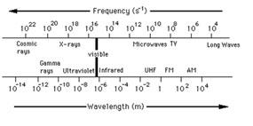
There are different types of IR sensors working in various regions of the IR spectrum but the physics behind "IR sensors" is governed by three laws:
1. Planck’s radiation law:
Every object at a temperature T not equal to 0 K emits radiation. Infrared radiant energy is determined by the temperature and surface condition of an object. Human eyes cannot detect differences in infrared energy because they are primarily sensitive to visible light energy from 400 to 700 nm. Our eyes are not sensitive to the infrared energy.
2. Stephan Boltzmann Law
The total energy emitted at all wavelengths by a black body is related to the absolute temperature as
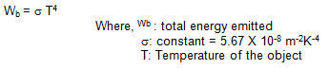
3. Wein’s Displacement Law
Wein’s Law tells that objects of different temperature emit spectra that peak at different wavelengths. It provides the wavelength for maximum spectral radiant emittance for a given temperature.
The relationship between the true temperature of the black body and its peak spectral exitance or dominant wavelength is described by this law
The world is not full of black bodies; rather it comprises of selectively radiating bodies like rocks, water, etc. and the relationship between the two is given by emissivity (E).
Emissivity depends on object color, surface roughness, moisture content, degree of compaction, field of view, viewing angle & wavelength.

ELEMENTS OF INFRARED DETECTION SYSTEM:
A typical system for detecting infrared radiation is given in the following block diagram:
Infra red detecors
Optical components
Transmission medium
Signal processing
Infra red source

1. Infrared Source
All objects above 0 K radiate infrared energy and hence are infrared sources. Infrared sources also include blackbody radiators, tungsten lamps, silicon carbide, and various others. For active IR sensors, infrared Lasers and LEDs of specific IR wavelengths are used as IR sources.
2. Transmission Medium
Three main types of transmission medium used for Infrared transmission are vacuum, the atmosphere, and optical fibers.
The transmission of IR – radiation is affected by presence of CO2, water vapour and other elements in the atmosphere. Due to absorption by molecules of water carbon dioxide, ozone, etc. the atmosphere highly attenuates most IR wavelengths leaving some important IR windows in the electromagnetic spectrum; these are primarily utilized by thermal imaging / remote sensing applications.
• Medium wave IR (MWIR:3-5 µm)
• Long wave IR (LWIR:8-14 µm)
Choice of IR band or a specific wavelength is dictated by the technical requirements of a specific application.
3. Optical Components.
Often optical components are required to converge or focus infrared radiations, to limit spectral response, etc. To converge/focus radiations, optical lenses made of quartz, CaF2, Ge and Si, polyethylene Fresnel lenses, and mirrors made of Al, Au or a similar material are used. For limiting spectral responses, band pass filters are used. Choppers are used to pass/ interrupt the IR beams.

4. Infrared detectors.
Various types of detectors are used in IR sensors. Important specifications of detectors are
- Photosensitivity or Responsivity
Responsivity is the Output Voltage/Current per watt of incident energy. Higher the better.
- Noise Equivalent Power (NEP)
NEP represents detection ability of a detector and is the amount of incident light equal to intrinsic noise level of a detector.
- Detectivity(D*: D-star)
D* is the photosensitivity per unit area of a detector. It is a measure of S/N ratio of a detector. D* is inversely proportional to NEP. Larger D* indicates better sensing element.
In addition, wavelength region or temperature to be measured, response time, cooling mechanism, active area, no of elements, package, linearity, stability, temperature characteristics, etc. are important parameters which need attention while selecting IR detectors.
5. Signal Processing
Since detector outputs are typically very small, preamplifiers with associated circuitry are used to further process the received signals.

TYPES OF INFRARED SENSORS
1. ACTIVE INFRARED SENSORS
Active infrared sensors employ both infrared source and infrared detectors. They operate by transmitting energy from either a light emitting diode (LED) or a laser diode. A LED is used for a non-imaging active IR detector, and a laser diode is used for an imaging active IR detector.
In these types of IR sensors, the LED or laser diode illuminates the target, and the reflected energy is focused onto a detector. Photoelectric cells, Photodiode or phototransistors are generally used as detectors. The measured data is then processed using various signal-processing algorithms to extract the desired information.
Active IR detectors provide count, presence, speed, and occupancy data in both night and day operation. The laser diode type can also be used for target classification because it provides target profile and shape data.
These sensors are used as reflective opto-sensors. Reflective opto-sensors are either intensity based or use modulated IR. Intensity based sensors are affected by ambient light. Modulated Infrared sensors wherein emitter is turned ON and OFF rapidly, are less susceptible to ambient light. Reflective opto-sensors are used in two configurations.
• Break Beam Sensors
This type of sensors consists of a pair of light emitting and light detecting elements. Infrared source transmits a beam of light towards a remote IR receiver creating an “electronic fence”. Once a beam is broken/ interrupted due to some opaque object, output of detector changes and associated electronic circuitry takes appropriate actions.
Typical applications of such sensors are intrusion detection, shaft encoder (for measurement of rotation angle/rate of rotation).

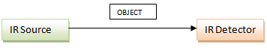

• Reflectance Sensors
This type of sensors house both an IR source and an IR detector in a single housing in such a way that light from emitter LED bounces off an external object and is reflected into a detector. Amount of light reflected into the detector depends upon the reflectivity of the surface.
This principle is used in intrusion detection, object detection (measure the presence of an object in the sensor’s FOV), barcode decoding, and surface feature detection (detecting features painted, taped, or otherwise marked onto the floor), wall tracking (detecting distance from the wall),etc.
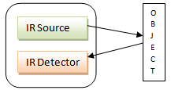

It can also be used to scan a defined area; the transmitter emits a beam of light into the scan zone, the reflected light is used to detect a change in the reflected light thereby scanning the desired zone.
2. PASSIVE INFRARED SENSORS
These are basically IR detectors; they don’t use any IR source. These form the major class of IR sensors/detectors.
A passive infrared system detects energy emitted by objects in the field of view and may use signal-processing algorithms to extract the desired information. It does not emit any energy of its own for the purposes of detection. Passive infrared systems can detect presence, occupancy, and count.
Passive Infrared Sensors are of two types: Thermal & Quantum.
Thermal type sensors have no wavelength dependence. They use the infrared energy as heat and their photosensitivity is independent of wavelength. Thermal detectors don’t require cooling but have disadvantages that response time is slow & detection time is low.
Common types of thermal type IR detectors are
• Thermocouple-Thermopile
A detector that converts temperature into an electrical signal is commonly known as a thermocouple. The junction of dissimilar metals generates a voltage potential, which is directly proportional to the temperature. This junction can be made into multiple junctions to improve sensitivity. Such a configuration is called a thermopile.
The active or ‘Hot’ junctions are blackened to efficiently absorb radiation. The reference or ‘Cold’ junctions are maintained at the ambient temperature of the detector. The absorption of radiation by the blackened area causes a rise in temperature in the ‘hot’ junctions as compared to the ‘cold’ junctions of the thermopile. This difference in temperature across the thermocouple junction causes the detector to generate a positive voltage. If the active or ‘hot’ junction were to cool to a temperature less than the reference or ‘cold’ junction the voltage output would be negative.
These detectors has a relatively slow response time, but offers the advantages of DC stability, requiring no bias, and responding to all wavelengths.
• Bolometer
A bolometer is a simple thermal or total power detector. A bolometer changes resistance when incident infrared radiation interacts with the detector. This thermally sensitive semiconductor is made of a sintered metal oxide material. It has a high temperature coefficient of resistance
It essentially consists of two main elements: a sensitive thermometer and an absorptive element and a heat sink. Absorber is connected by a weak thermal link to a heat sink (at temperature T0). Incoming energy increases the temperature of the absorptive element above that of a heat sink and rise in temperature is measured by a thermometer.
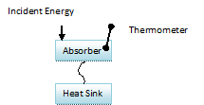

Delta T = T - T0 = E/C
Bolometer use metals or semiconductor/superconductors as absorptive elements.

• Pyroelectric detector
Pyroelectric detectors use PZT having pyroelectic effect, a high resistor and a low noise FET, hermetically sealed in a package. Pyroelectric materials are crystals, such as lithium tantalate, which exhibit spontaneous polarization, or a concentrated electric charge that is temperature dependent. PZT is spontaneously polarized in dark state. As infrared radiation strikes the detector surface, the change in temperature causes a current to flow. This results in change of polarization state which is reflected in terms of voltage change at the output.
This detector exhibits good sensitivity and good response to a wide range of wavelengths, and does not require cooling of the detector. It is the most commonly used detector for gas monitors.
Quantum type offer higher detection performance and a faster response speed although their photosensitivity is wavelength dependant. Quantum type detectors require cooling for accurate measurements (except for those in near IR region).Quantum type detectors are further classified into two categories
• Intrinsic type
- Photoconductive
Photoconductive type of IR detectors makes use of photoconductive effect. This effect causes change in resistance when IR radiation falls upon detecting elements.
Examples are PbS, PbSe, MCT (HgCdTe)
Bandgap of PbS, PbSe have negative temperature coefficient and hence their spectral response characteristics shift to long wavelength region when cooled. However, bandgap of HgCdTe depends upon the composition and therefore, spectral response characteristics can be tailored to suit the requirements.
- Photovoltaic
Photoconductive type of IR detectors makes use of photovoltaic effect. Incident IR light cause increase in voltage output of these detectors.
Examples are InGaAs PIN photodiodes, InAs, InSb

- Extrinsic type
Various types of detectors like Ge:Au, Ge:Hg, Ge:Cu, Ge:Zn, Si:Ga, Si:As and are used depending upon the requirements of the application- spectral response, D*, etc.

APPLICATIONS OF INFRA RED RADIATION
1. Radiation thermometers
Compared to various other methods of temperature measurement, radiation thermometers have following features
a) Measurement without direct contact with the object
b) Faster response
c) Easy pattern measurements.
Detectors used for radiation thermometers depend upon the temperature and material of the object to be measured. For example, glass have peak wavelength near 5 µm and hence, detectors sensitive to these wavelengths are used.
2. Flame monitors
Flame monitors are used for detecting light emitted from the flames and to monitor how the flames are burning. Light emitted from flames extend from UV to IR region. PbS, PbSe, Two-color detector, pyroelectric detector, etc. are some of the commonly employed detector used in flame monitors.
3. Moisture analyzers
These analyzers use those wavelengths which are absorbed by moisture in IR region, i.e., 1.1 µm, 1.4 µm, 1.9 µm, and 2.7 µm. Objects are irradiated with light having these wavelengths and also with reference wavelengths. Lights reflected from the objects depend upon the moisture content and is detected by analyzer to measure moisture (ratio of reflected light at these wavelengths to the reflected light at reference wavelength). InGaAs PIN photodiodes, PbS photoconductive detectors are employed in moisture analyzers.

4. Gas Analyzers
Gas analyzers use absorption characteristics of gases in IR region to measure gas density. Two types of methods are used
a) Dispersive: Emitted light is spectroscopically divided and their absorption characteristics are used to analyze the gas ingredients and the sample quantity.
b) Nondispersive: It is more commonly used; it uses absorption characteristics without dividing the emitted light. Nondispersive types use discrete optical bandpass filters, similar to sunglasses that are used for eye protection to filter out unwanted UV radiation. This type of configuration is commonly referred to as nondispersive infrared (NDIR).
Dispersive or ingredient analyzer is used for carbonated drinks, whereas nondispersive analyzer is used in most of the commercial IR instruments, for automobile exhaust gases fuel leakages, etc.
5. IR Imaging devices
This is one of the prime applications of IR waves, primarily by virtue of its property that it is not visible. It is used for thermal imagers, night vision devices, etc.
Water, rocks, soil, vegetation, the atmosphere, and human tissue all features emit IR radiation. Thermal infrared detectors measure these radiations in IR range and map the spatial temperature distributions of the object/area on an image. Thermal imagers usually composed of In:Sb (indium antimonide), Gd:Hg (mercury-doped germanium), Hg:Cd:Te (mercury-cadmium-telluride)
The detectors are cooled to low temperatures using liquid helium or liquid nitrogen. Cooling the detectors insures that the radiant energy (photons) recorded by the detectors comes from the terrain and not from the ambient temperature of objects within the scanner itself.
6. Remote sensing
As all objects emit light, the measurement of each wavelength of this emitted light provides lots of specific information about the object. This is precisely what is done in remote sensing to obtain information like temperature of land and sea water, gas concentration of atmosphere, etc.

7. Missile Guidance
Missiles use passive infrared guidance system wherein Infrared energy emitted by a target is used for homing. Infrared seekers are used in missiles for this purpose.
8. Optical Power meters
For long distance optical communication systems, IR beams in the wavelength region from 1.3 to 1.5 are employed. Optical power meters are used to measure light intensity, optical fiber transmission loss, laser power, etc. in applications like optical fiber communications, lasers, etc. They use InGaAs PIN photodiodes, etc. for optical power measurement.
9. Sorting devices
These devices use the inherent property of absorption of some IR wavelengths to sort agricultural crops from stones, clods, etc. Such devices use InGaAs PIN photodiodes, PbS detectors.
10. Human body detection
Such devices are used for detection of a person. Typical applications are intrusion detection, auto light switches, etc. Intrusion alarm devices sense the temperature of a person and rings alarm if sensed temperature crosses some threshold. Such devices also employ optical filters to make use of a specific window (appropriate for human body) of electromagnetic spectrum and to protect it from external disturbances.
11. Spectrophotometers(FT-IR)
Infrared detectors are at the heart of Fourier Transform IR. In FTIR spectrophotometry, interference signal from double beam interferometer undergoes Fourier transformation by which signal is decomposed into a spectrum.
12. LD Monitors
The output level and emission wavelength of a Laser Diode varies with the temperature. For the purpose of automatic stabilization of Laser Diode emission wavelength, Laser diode power is monitored using InGaAs PIN photodiodes, InAs, InSb detectors, etc

Advantages:
1. Low power requirements: therefore ideal for laptops, telephones, PDAs
2. Low coding/decoding, simple circuitry.
3. Beam directionality ensures that data isn't leaked or spilled to nearby devices during transmission.
4. Few international regulatory constraints.
5. Relatively high noise immunity.
Overview of IR sensor:
This sensor can be used for most indoor applications where no important ambient light is present. For simplicity, this sensor doesn't provide ambient light immunity, but a more complicated, ambient light ignoring sensor should be discussed in a coming article. However, this sensor can be used to measure the speed of object moving at a very high speed, like in industry or in tachometers. In such applications, ambient light ignoring sensor, which rely on sending 40 Khz pulsed signals cannot be used because there are time gaps between the pulses where the sensor is 'blind'.
The solution proposed doesn't contain any special components, like photo-diodes, photo-transistors, or IR receiver ICs, only a couple if IR led’s, an Op amp, a transistor and a couple of resistors. In need, as the title says, a standard IR led is used for the purpose of detection. Due to that fact, the circuit is extremely simple, and any novice electronics hobbyist can easily understand and build it.
Object Detection using IR light:
It is the same principle in ALL Infra-Red proximity sensors. The basic idea is to send infra red light through IR-LEDs, which is then reflected by any object in front of the sensor.
Then all you have to do is to pick-up the reflected IR light. For detecting the reflected IR light, we are going to use a very original technique: we are going to use another IR-LED, to detect the IR light that was emitted from another led of the exact same type!
This is an electrical property of Light Emitting Diodes (LEDs) which is the fact that a led produces a voltage difference across its leads when it is subjected to light. As if it was a photo-cell, but with much lower output current. In other words, the voltage generated by the led’s can't be - in any way - used to generate electrical power from light, It can barely be detected. That’s why as you will notice in the schematic, we are going to use a Op-Amp (operational Amplifier) to accurately detect very small voltage changes

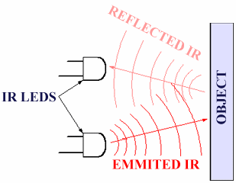

Passive infrared sensor

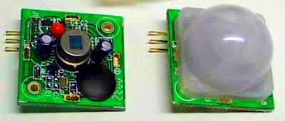

A passive infrared sensor (PIR sensor) is an electronic sensor that measures infrared (IR) light radiating from objects in its field of view. They are most often used in PIR-based motion detecto

Operating principles
All objects above absolute zero emit heat energy in the form of infrared radiation (infrared light). Usually infrared light is invisible to the human eye, but it can be detected by electronic devices designed for such a purpose.
The term passive in this instance refers to the fact that PIR devices do not generate or radiate any energy for detection purposes. They work entirely by detecting the energy given off by other objects.

PIR-based motion detector
A PIR-based motion detector is used to sense movement of people, animals, or other objects. They are commonly used in burglar alarms and automatically-activated lighting systems. They are commonly called simply "PIR," or sometimes "PID," for 'passive infrared detector'.

Operation
Strictly speaking, individual PIR sensors do not detect motion; rather, they detect abrupt changes in temperature at a given point. As an object, such as a human, passes in front of the background, such as a wall, the temperature at that point will rise from room temperature to body temperature, and then back again. This quick change triggers the detection. Moving objects of identical temperature will not trigger detection. PIDs can be equipped with more than one internal sensing element so that, with the appropriate electronics, it can detect the apparent direction of movement. As an object passes in front of adjacent sensors in turn, this implies the direction of movement. This may be used by on-board electronics to reduce false alarms, i.e., by requiring adjacent sensors to trip in succession. It may also be used to signal the direction of movement to a monitoring apparatus.
PIDs come in many configurations for a wide variety of applications. The most common models have numerous Fresnel lenses or mirror segments, an effective range of about ten meters (thirty feet), and a field of view less than 180 degrees. Models with wider fields of view, including 360 degrees, are available -- typically designed to mount on a ceiling. Some larger PIDs are made with single segment mirrors and can sense changes in infrared energy over one hundred feet away from the PID. There are also PIDs designed with reversible orientation mirrors which allow either broad coverage (110° wide) or very narrow "curtain" coverage or with individually selectable segments to "shape" the coverage.

Software Tools
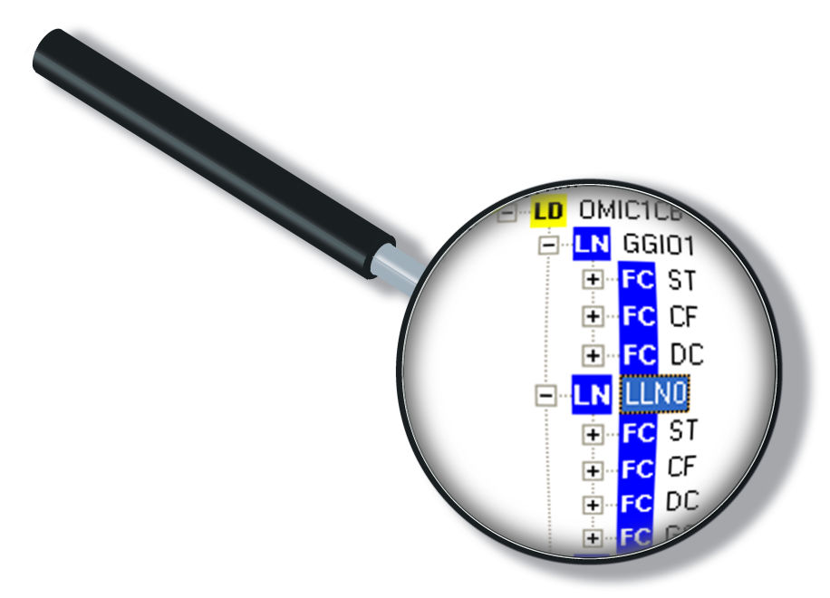
KEIL SOFTWARE:
Keil compiler is a software used where the machine language code is written and compiled. After compilation, the machine source code is converted into hex code which is to be dumped into the microcontroller for further processing. Keil compiler also supports C language code.
STEPS TO WRITE AN ASSEMBLY LANGUAGE PROGRAM IN KEIL AND HOW TO COMPILE IT:

- Install the Keil Software in the PC in any of the drives.
- After installation, an icon will be created with the name “Keil uVision3”. Just drag this icon onto the desktop so that it becomes easy whenever you try to write programs in keil.
- Double click on this icon to start the keil compiler.
- A page opens with different options in it showing the project workspace at the leftmost corner side, output window in the bottom and an ash coloured space for the program to be written.
- Now to start using the keil, click on the option “project”.
- A small window opens showing the options like new project, import project, open project etc. Click on “New project”.
- A small window with the title bar “Create new project” opens. The window asks the user to give the project name with which it should be created and the destination location. The project can be created in any of the drives available. You can create a new folder and then a new file or can create directly a new file.
- After the file is saved in the given destination location, a window opens where a list of vendors will be displayed and you have to select the device for the target you have created.
- The most widely used vendor is Atmel. So click on Atmel and now the family of microcontrollers manufactured by Atmel opens. You can select any one of the microcontrollers according to the requirement.

- When you click on any one of the microcontrollers, the features of that particular microcontroller will be displayed on the right side of the page. The most appropriate microcontroller with which most of the projects can be implemented is the AT89C51. Click on this microcontroller and have a look at its features. Now click on “OK” to select this microcontroller.
- A small window opens asking whether to copy the startup code into the file you have created just now. Just click on “No” to proceed further.
- Now you can see the TARGET and SOURCE GROUP created in the project workspace.
- Now click on “File” and in that “New”. A new page opens and you can start writing program in it.
- After the program is completed, save it with any name but with the .asm extension. Save the program in the file you have created earlier.
- You can notice that after you save the program, the predefined keywords will be highlighted in bold letters.
- Now add this file to the target by giving a right click on the source group. A list of options open and in that select “Add files to the source group”. Check for this file where you have saved and add it.
- Right click on the target and select the first option “Options for target”. A window opens with different options like device, target, output etc. First click on “target”.
- Since the set frequency of the microcontroller is 11.0592 MHz to interface with the PC, just enter this frequency value in the Xtal (MHz) text area and put a tick on the Use on-chip ROM. This is because the program what we write here in the keil will later be dumped into the microcontroller and will be stored in the inbuilt ROM in the microcontroller.
- Now click the option “Output” and give any name to the hex file to be created in the “Name of executable” text area and put a tick to the “Create HEX file” option present in the same window. The hex file can be created in any of the drives. You can change the folder by clicking on “Select folder for Objects”.
- Now to check whether the program you have written is errorless or not, click on the icon exactly below the “Open file” icon which is nothing but Build Target icon. You can even use the shortcut key F7 to compile the program written.
- To check for the output, there are several windows like serial window, memory window, project window etc. Depending on the program you have written, select the appropriate window to see the output by entering into debug mode.
- The icon with the letter “d” indicates the debug mode.
- Click on this icon and now click on the option “View” and select the appropriate window to check for the output.
- After this is done, click the icon “debug” again to come out of the debug mode.
- The hex file created as shown earlier will be dumped into the microcontroller with the help of another software called Proload.
PROLOAD:
Proload is a software which accepts only hex files. Once the machine code is converted into hex code, that hex code has to be dumped into the microcontroller placed in the programmer kit and this is done by the Proload. Programmer kit contains a microcontroller on it other than the one which is to be programmed. This microcontroller has a program in it written in such a way that it accepts the hex file from the keil compiler and dumps this hex file into the microcontroller which is to be programmed. As this programmer kit requires power supply to be operated, this power supply is given from the power supply circuit designed above. It should be noted that this programmer kit contains a power supply section in the board itself but in order to switch on that power supply, a source is required. Thus this is accomplished from the power supply board with an output of 12volts or from an adapter connected to 230 V AC.
- Install the Proload Software in the PC.
- Now connect the Programmer kit to the PC (CPU) through serial cable.
- Power up the programmer kit from the ac supply through adapter.
- Now place the microcontroller in the GIF socket provided in the programmer kit.
- Click on the Proload icon in the PC. A window appears providing the information like Hardware model, com port, device type, Flash size etc. Click on browse option to select the hex file to be dumped into the microcontroller and then click on “Auto program” to program the microcontroller with that particular hex file.
- The status of the microcontroller can be seen in the small status window in the bottom of the page.
- After this process is completed, remove the microcontroller from the programmer kit and place it in your system board. Now the system board behaves according to the program written in the microcontroller.

